INSTRUCTIONS FOR THE USE OF THE TEMPLATE FOR CONTRIBUTIONS WRITING

INFORMATION TECHNOLOGY CENTRE
Masaryk University, Faculty of Law
Abstract in original language
Write an abstract in a language of the paper. Range 5-7 lines.
Key words in original language
Write keywords in the language of the contribution here.
Abstract
This article describes how to write paper and how to use the template
Key words
Template, styles.

  - The BASIC INFORMATION ON THE template
The contributions will not be checked, edited or otherwise professionally modified. Thus, it is necessary to ensure their mutual compatibility, for the contributions will be published in their entirety in a single conference proceeding. This is the reason why only the contributions in the file format ".doc" created in the MS Office Word editor template may be accepted.
The template has had a required structure of the contribution and enables solely to use allowed styles. Therefore, it is not possible to use the individual style of the text formatting. The appearance of the page is also preset and it is not to be changed.
  - Filling up the forms in the heading
Please, start by filling in the grey fields of the template, your name, faculty, keywords and abstracts in the Czech and English. In order to fill the information in, it is sufficient to click (once) into the field and start writing. Then, the grey field will be automatically substituted for the text which you have been writing. In any case, do not change the style in the grey fields or make the text in the bold font style. Please, do not rewrite or erase the text out of the grey fields.
  - The text of the contribution
Click on the form field for the contribution and start writing your contribution. You can format and structure the text exclusively by using the styles. In order to keep the unified style of the contributions in the conference proceedings, it is not allowed to use the additional hand text formatting.
You may find the appropriate styles in the menu "Style" placed on the left side of the "Selection of type" menu in the "Tools panel". For application of the certain style to the paragraph, mark the paragraph and then choose the required style in the menu "Style". If you need to highlight certain part of the text, mark the required text and choose the style from the "Style".
The paragraph styles are set so as to include the gap beneath each paragraph. Hence, please, do not insert an extra line by pressing the ENTER key into the text. If you insert an extra line by pressing the ENTER, it could cause the disturbance of the flow of the document thus undesirable order of the text (e.g. the heading placed in the end of the page or the empty line in the top of the page, etc.).
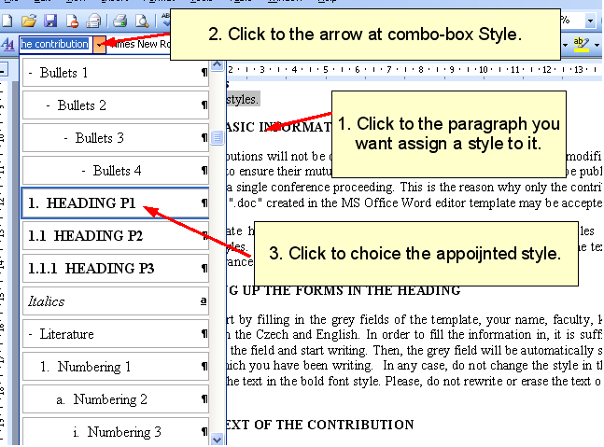
Picture 1 How to select style of a paragraph
    - Heading in the contribution
Three levels of headlines may be used in the contribution: Heading P1, Heading P2 and Heading P3. The headlines are numbered automatically. We strictly recommend you using of these styles for the headlines, otherwise it can cause troubles with the formatting. Please, do not highlight the headings and do not also insert the empty lines beneath the paragraphs; the extra gap will be automatically set by the style.
In these instructions all of three levels of headlines are used.
    - Paragraphs
The style "Text of the contribution" is intended for ordinary paragraphs. We just remind you that the style contains the gap beneath the line, therefore the sole way how to finish the paragraph is the only pressure of the ENTER key in the end. Otherwise it can cause an unwanted order of the text (e.g. a heading placed at the end of the page or an empty line at the top of the page) which will lead to the problems with its publishing.
If you need to highlight the part of the text, please use the styles "Italics" and "Bold". However, please bear in mind that these styles are not allowed to be used in headings.
    - Numbered lists and lists with bullets
There are following styles for the 1–4 levels of numbered lists: Numbering 1, Numbering 2, Numbering 3 and Numbering 4. The lists are numbered automatically. The way how to use them is shown below.
- Lorem ipsum dolor sit amet, consectetuer adipiscing elit.
  - Nulla viverra aliquam arcu.
  - Integer eget nulla at urna cursus dapibus.
    - Donec lobortis gravida augue.
      - Maecenas imperdiet nisl at odio.
    - Vivamus nec dolor ut diam mollis feugiat.
  - Curabitur interdum varius justo.
- Vestibulum id lectus ac est aliquet iaculis.
  - Morbi nec enim ornare lectus convallis interdum.
    - Curabitur dignissim nunc eget neque.
    - Vestibulum scelerisque ullamcorper augue.
      - Cras feugiat eleifend orci.
      - Duis gravida felis eu urna.
- Curabitur lobortis sodales mauris.
In case you need to number the list from the beginning instead of continuing from the previous list, click the right button of the mouse on the first number in the list and choose "Numbering from the beginning."
In order to create numbered lists use solely these styles. The hand numbering is absolutely inadmissible, for it may cause the disturbance of the format when printing the final text.
There are four styles for the four levels of lists of bullets: Bullet 1, Bullets 2, Bullets3 and Bullets 4. The illustration is shown beneath.
- Lorem ipsum dolor sit amet, consectetuer adipiscing elit.
  - Pellentesque et velit non odio venenatis mattis.
    - Suspendisse condimentum elit a justo.
    - Aliquam sit amet mauris sit amet lacus suscipit interdum.
      - Nullam dictum interdum leo.
      - Duis convallis dolor vitae elit vehicula facilisis.
    - Fusce cursus orci in justo gravida fringilla.
  - Sed sed velit eget leo dignissim venenatis.
  - Donec id lorem at sapien tristique sagittis.
- Curabitur auctor ornare neque.
  - Maecenas convallis justo id leo.
    - Nulla blandit magna et tellus.
    - Phasellus sed diam at mauris tincidunt commodo.
      - Integer consectetuer commodo eros.
      - Donec tempor orci nec justo.
      - Aenean mollis augue quis odio.
  - Cras euismod consectetuer magna.
- Nam blandit leo ac est.
We strongly recommend you to use exclusively these styles. The hand-writing bullets (e.g. dashes or stars) or using of the tabulator or spacebar buttons is not allowed, since it can cause the disturbance of the format when printing the final text and to disorganize the unified appearance of the conference proceedings.
    - Tables
You may create the tables in MS Office Word editor and use automatic formatting. The "Table” style is the only and in the same time original style. For the purpose of the headings or summary, there is set the bold font for the first and the last line and the first and last paragraph. If you do not need or intent to use this function, you can cancel it by the crossing the certain grey field (see Art 2).
If the different format of the marginal cells has not automatically occurred when creating the table, despite the choice of the mentioned format, mark all of the cells and set the style "Text of the contribution" for them.
If the text in the cell is too long and the cell has to be divided into more lines, the all lines will be automatically moved to another page. If you cross the grey field "Form the lines of the headings differently" and the table does not fit into the page, the first line of the table will be automatically duplicated at the other pages.
We kindly ask you not to insert the tables created in other programs into the template as a picture. It may cancel the unified format of the contributions.
Please, write the caption under every table. How to insert the table is described beneath.
Column 1 | Column 2 | Column 3 | Sum
1 | 2 | 3 | 6
4 | 5 | 6 | 15
7 | 8 | 9 | 24
12 | 15 | 18 | 45
Table 1Illustration of the table
    - Pictures
Please insert the pictures into the text of the paragraphs. Then, choose the style "Picture" for them. As a next step, write the illustration below the each picture. Please do not use this style for other purposes.
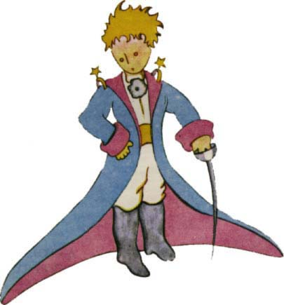
Picture 2Illustration of the Picture (author Antoine de Saint-Exupéry)
    - Captions
The captions are inserted in standard way, thus there is no special style to be used. The Use of the standard Word tools ensures the fluent numbering and unified appearance of the text.
Following methods are intended for those of the authors who do not know how to insert captions under the picture or the table and write them by hand instead. The hand-made use of captions is not allowed.
      - Table
- Mark the table
- Menu Insert/Reference/Caption
- In the part Options choose “Table” in the roller Label
- Choose placement under the chosen object
- Write the text of caption into the field "Caption" in the upper part of the form behind the Table x.
- Click the button OK.
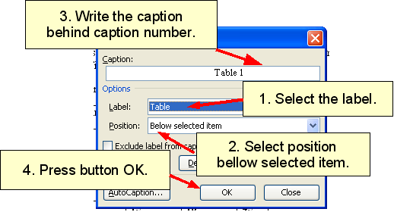
Picture 3How to insert a caption
      - Picture
- Click in the picture by the right button of the mouse.
- Choose "Caption".
- Choose Picture in the combo box Label in the part Options.
- Choose the placement under the chosen object.
- Write the text of illustration into the field "Caption" in the upper part of the form behind the Picture x.
- Click the button OK.
    - Footnote
You can insert the footnotes in the usual way.
  - Headers and footers
Do not fill up the header and footer and do not number the pages.
  - Literature
Fill up the list of the literature under the text of the contribution under the headings "Literature" Please, cite in accordance with the Czech norm ISO 690-2 for the citations or the Dean's Directive no. 1/2006, O úpravě rukopisů písemných prací a o citaci dokumentů užívaných v pracích podávaných na Právnické fakultě MU; accessible from http://www.law.muni.cz/dokumenty/409.
  - Contact address
Please write only the electronic address, do not write the mailing address, please.
Literature:
- Author, M. et al: Name, Town: publisher, year of publishing, number of pages, ISBN
Contact – email
author@domain.com

I.e..Insert/Reference/Footnote.

