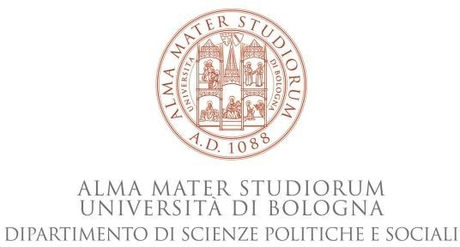 | 

Tuesday, 3rd May 2022
12 – 1.30 pm (Italian time)

Virtual room:
https://teams.microsoft.com/l/meetup-join/19%3ameeting_MjA4ZmI2YmQtNDMyOS00NDdhLWFlZjAtYTY2MzRlNzBkM2Iz%40thread.v2/0?context=%7b%22Tid%22%3a%22e99647dc-1b08-454a-bf8c-699181b389ab%22%2c%22Oid%22%3a%22235e8b20-a5b6-41c4-8c34-27de0e83a9e9%22%7d

Seminar in the course “Organization theory and behavior” (LM-59)
Professor Cristina Dallara

In collaboration with the Centre for Migration Studies, Law Faculty of the Masaryk University
http://migrationcentre.law.muni.cz/content/en/

Book presentation
Rules, Paper, Status: Migrants and Precarious Bureaucracy in Contemporary Italy

Stanford University Press (2018)

Winner of the 2019 William A. Douglass Prize in Europeanist Anthropology

Anna Tuckett
Lecturer in Anthropology, Brunel University London

Organizer: Cristina Dallara (Professor in Political and Social Sciences – University of Bologna)
Discussant: Alice Lacchei (PhD Student in Political and Social Sciences – University of Bologna)

