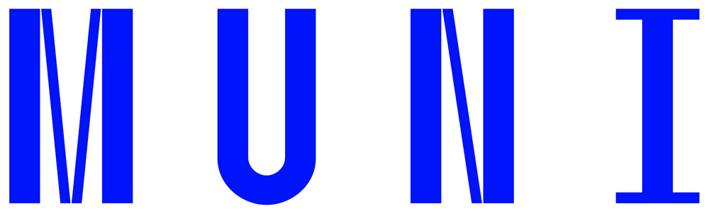
Learning Agreement for a short period study/research stay
(research in libraries, archives; conferences etc. up to 14 days with no course/credit recognition at MU, not for an internship)
Name of the student: ………………..………………………………………………………  MU ID (UČO): ……………………….  Email address: |  |  | Country: CZECH REPUBLIC
Home university: MASARYK UNIVERSITY |  |  | Academic Year: ………………..……………
MU faculty and field of study at the home university:
Host institution: …………....…................................................ (in English) |  |  | Country: ………………..………………………..……………………………. (in English)
Stay period at the host institution: from ………………..……………………….. (dd.mm.yyyy) to ………………………………………… (dd.mm.yyyy)
Purpose of the stay: (in English):

Use more space, if needed
By signing this document, the student, Masaryk University and the Receiving Organization confirm that they approve the Learning Agreement and that they will comply with all the arrangements agreed by all parties.
 | Name | Email |  | Date | Signature
MU student | - | -
MU responsible person
Host institution responsible person

Confirmation of STAY For a Short Period study/research stay

Host institution: This is to certify that the student mentioned above stayed at our institution and completed the Learning agreement purpose of stay listed above.
from ………………..…………………………..… (dd.mm.yyyy) to …..………………..……………… (dd.mm.yyyy)
 | Name | Email | Date | Signature
Host institution responsible person

